Issue 1: Receiving spanning-tree error message across all switches in Fallout Shelter causing ports to flap.

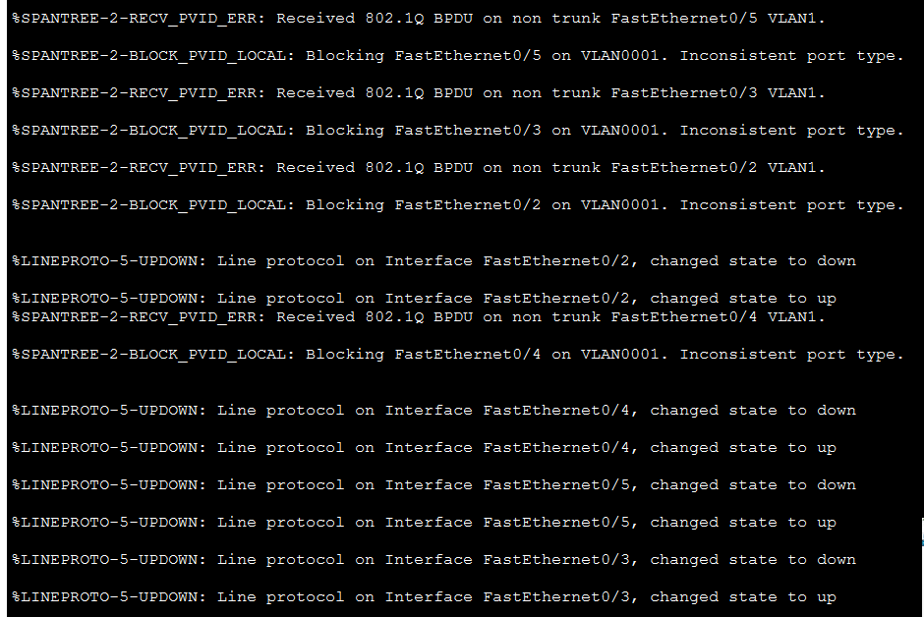
Investigation:
- “show run” across all switches and routers show interface Vlan1 is shutdown
- “show int trunk” on all switches shows all trunking ports connecting switches are set to trunk mode via DTP desirable mode “encapsulation: n-802.1q” (ports 2-5 on Switches 1 and 2, ports 1-2 on switches 3-6), also shows Vlans 1-1005 are allowed on all trunk ports
- Port 1 on both Switch 1 and 2 are manually set to trunk mode via “switchport mode trunk” trunk and on corresponding router interfaces via “Encapsulation dot1q #” on sub-interfaces
- “Show spanning-tree inconsistentports” states 0 inconsistent ports (segments) in the system on all devices
- “Show spanning-tree vlan 1” on all switches shows RSTP is configured and on switches 3-6 Fa0/1 port (switch 1 connection) is designated forwarding and Fa0/2 is alternate blocking (connection to switch 2), on Switch 1 all ports are designated forwarding including port channel 1, on switch 2 all ports are designated blocking, and port channel 1 is alternate blocking.
- Reloading all switches and switch 2 states configuration has changed and if I want to save config before reload. Canceling out of reload and issuing “show run” shows no discernible change in running config. So reload without saving.
- Post-reload “show int trunk” on all devices shows no change except on switch 2 which shows port Fa0/5 in forwarding state and not pruned for Vlan 1
- “Show spanning-tree vlan 1” on switch 2 shows ports fa0/1-4, 6-7 and Po1 for vlan are blocking but port fa0/5 is forwarding. Shows cost of 19 on port Fa0/5 but 12 on Po1 so Po1 should be the forwarding port not fa0/5.
- “Show spanning-tree vlan 1” on switch 6 shows that vlan 1 is pruned from port Fa0/2 (port connecting to switch2)
- Tested if packet tracer issue (been at this for a couple hours now). Closed and restarted Packet tracer. “show int trunk” Switch 2 showed no vlan 1 on any forwarding state ports but ports still flapping on logical overview.
- Issuing reload command on switch 2 then “show int trunk” shows fa0/4 as spanning-tree forwarding state and not pruned for vlan 1.
- “show spanning-tree summary” on Routers 1 and 2 showed still in pvst mode instead of rapid-pvst mode. Set both to rapid mode using “spanning-tree mode rapid-pvst” command. Issue still persists.
- “show etherchannel port-channel” on switch 1 and 2 both show ports fa0/6 and 7 are active in PO1.
- Going back into ports Fa0/6 and Fa0/7 on switch 2 and retyping “switchport mode dynamic desirable” results in both ports going down then back up on switch 2 and “FO-SW01#%SPANTREE-2-UNBLOCK_CONSIST_PORT: Unblocking Port-channel1 on VLAN0040. Port consistency restored. %SPANTREE-2UNBLOCK_CONSIST_PORT: Unblocking Port-channel1 on VLAN0001. Port consistency restored.” appearing on switch1.
- Doing same on switch 1 results in ports going down then back up on switch 1 and “%SPANTREE-2-RECV_PVID_ERR: Received 802.1Q BPDU on non trunk Port-channel1 VLAN1. %SPANTREE-2-BLOCK_PVID_LOCAL: Blocking Port-channel1 on VLAN0001. Inconsistent port type.” on Switch 2.
Cause: Not a clue, assuming bug in Cisco Packet Tracer as it’s going crazier and crazier
Thoughts on reason for outcome: I think this is a bug in cisco packet tracer as the error messages went away after restarting switches and the packet tracer program. It’s only flapping on logical ports for switch 2. but investigations show the ports are correct. Spent a few hours here trying to figure it out, and not sure what’s wrong as vlan1 is effectively shut down on all devices because all vlan 1 interfaces are shutdown.
Further later Exploring: Going through and manually setting all trunk interfaces to “switchport mode trunk” fixed issue and all STP ports are blocking as expected and no VLAN errors. but packet tracer froze and glitched out multiple times (switch 5 became un-interactive to reload, the buttons in the menus did nothing).

Test 1: What happens if active router goes down.
Setup: Ping 1.1.1.1 continuously on PC1 of Fallout shelter using ping -t 1.1.1.1 command to simulate host device attempting to ping somewhere on internet while internet connection drops on Fallout Router 1
Test 1.1: Shut down interface fa0/0.10 on router 1 with the shutdown command.
Expectation: Standby router 2 will take over for router 1 becoming active router and proceed to send traffic out for PC1
Outcome: Standby router 2 took over for router 1
Reason for Outcome: Because the port was manually shutoff, HSRP immediately sent a “resign hello” message out to standby router. When router 2 receives the packet it immediately takes over as the active forwarding router.
Test 1.2: unplug the cable for internet-facing interface on router1
Expectation: Standby router 2 will take over for router 1 becoming active router and proceed to send traffic out for router 1
Outcome: Standby router 2 forwards the ICMP for router 1, but because router 1 forwards the ICMP packet to it, router 2 never becomes active router.
Reason for Outcome: Because the interface connection went down but the router stayed up, the active router continued to send HSRP Hello messages, instead of resign hello messages, and be the default-gateway for incoming pings. When it received traffic for the default-gateway it instead then forwarded the packets to the standby router which then forwarded the packets out (and back to PC1 based on IP address). The active router never swapped to the standby router despite losing it’s route.
Test 1.3: Unplug the cable from Switch01 to Router 1
Expectation: Standby router 2 will take over for router 1 becoming active router and proceed to send traffic for PC1
Outcome: Standby router 2 takes over for router 1 and becomes the active router and proceeds to forward traffic.
Reason for Outcome: Because Standby router 2 has not received a hello message from previous active router 1 after the HSRP hold timer has run out router 2 becomes the active router and proceeds to forward traffic. Router 1 stays active router but is unable to send hello messages on the downed interface and thus cannot forward traffic or communicate with the standby router 2.

